#### Traditional MOEA approaches

1. **MOEA method based on experts’ experiences**

We invited human experts to perform typical PI controller tuning through 5–10 steps based on traditional human–computer interactions. Figure 7 shows six times PI controller tuning by an expert. Table 2 shows the relevant data during the interactions.

|  |
| --- |
| **Figure 7a.** Performances of original coupling loops. |
| **Figure 7b.** First decision step. |
| **Figure 7c.** Sixth decision step. |

**Figure 7.** PI controller tuning based on traditional MOEA method with experts’ experiences.

We can see that the satisfactory PI parameters were obtained after several interaction steps in Figure 7.

**Table 2.** Control performances during PI parameter tuning

|  |  |  |  |  |  |  |  |
| --- | --- | --- | --- | --- | --- | --- | --- |
| Interactive  number | [Kp1, Ki1, Kp2, Ki2] | Control performance | | | | Coupling performance | OAI |
| Adjustment time (s) | | R1 | | R2 |
| ISE1 | ISE2 |
| T1 | T2 |
| 1 | [0.0648,0.00405,1.815,0.00641] | $$>100$$ | $$>100$$ | ∕ | ∕ | 188,762.89 | 76928.56 |
| 2 | [0.1,0.0001,1.6,0.1] | >100 | $$>100$$ | ∕ | ∕ | 74,872.52 | 30,429.14 |
| 3 | [0.1,0.0001,1.0,0.1] | >100 | $$>100$$ | ∕ | ∕ | 58,110.35 | 23,630.39 |
| 4 | [0.1,0.0001,0.1,0.001] | 25 | 20 | 2.18 | 53.76 | 290.27 | 133.64 |
| 5 | [0.1,0.0001,0.8,0.001] | 21 | 70 | 1.74 | 41.28 | 92.21 | 55.34 |
| 6 | [0.1,0.0001,1.2,0.01] | 20 | 32 | 1.38 | 17.87 | 88.41 | 45.04 |

1. **MOEA based on NSGAII and MOEA_D**

Considering two subproblems in Equation (18), we used two classical MOEA approaches of NSGAII [19] and Decomposition MOEA (MOEA_D) [10] to optimize the decision vector [Kp1, Ki1, Kp2, Ki2]. The main comparative performances are shown in Table 3, and the detailed codes are presented in Appendix.

**Table 3**. Main comparative performances between NSGAIIand MOEA_D approaches

|  |  |  |  |
| --- | --- | --- | --- |
| Method | Number of iterations | Optimized decision vector | OAI |
| NSGAII [19] | 50 | [Kp1, Ki1, Kp2, Ki2] = [0.17, 0.01, 0.5, 0.00] | 29.87 |
| MOEA_D [10] | 50 | [Kp1, Ki1, Kp2, Ki2] = [0.29, 0.01, 0.15, 0.01] | 52.41 |

#### Fuzzy control [22]

In this experiment, the fuzzy control approach [22] was used to decouple the control loops, and each loop in the coupled loops employed the same fuzzy rules. The detailed calculation steps for one loop are listed as follows.

**Step 1:** Considering one control loop, we established the fuzzy sets involving the deviation E between the loop setpoint value and the real output value, referred to as the deviation change value Ec. The corresponding PI parameters Kp, Ki, E, and Ec were used to control Kp and Ki based on the fuzzy rules (**Appendix**).

**Step 2:** For each control loop, the fuzzy sets E and Ec were both designed as seven linguistic values ​​{NB, NM, NS, ZO, PS, PM, and PB}. Also, the membership function had a triangular shape.

**Step 3:** The fuzzy sets Kp andKi were both designed as seven linguistic values. The domain of fuzzy sets of Kp was (0, 2), and the domain of fuzzy sets of Ki was (0, 0.001). Also, the membership function had a triangular shape.

**Step 4:** The detailed fuzzy rule base is shown in **Appendix**.

Based on the optimum PI controller parameters (Kp1 = 0.347, Ki1 = 0.000667, Kp2 = 1.04313, Ki2 = 0.000478), the OAI was achieved as 164.6405 after fuzzy control decoupling. The dual-loop response curves are shown in Figure 8.

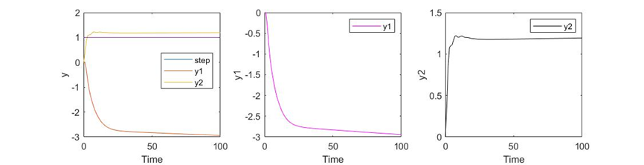

**Figure 8.** Response curves based on the fuzzy control decoupling approach.

#### Iterative learning control

In this experiment, we used the open-loop ILC approach [24] to optimize the PI controller parameters of the dual-loop system. According to the six decision vectors obtained by six human–computer interaction steps (Table 2), the decision vectors were used as the trajectory of iterative learning within 20 times iterations. The parameters of the ILC algorithm are shown in Table 4.

**Table 4.** Parameters of the ILC algorithm

|  |  |  |  |
| --- | --- | --- | --- |
|  | Undetermined parameters | Number of iterations | Manipulation updating factor |
| Values | [Kp1, Ki1, Kp2, Ki2] | 20 | 0.3 |

Based on the obtained optimum PI controller parameters (Kp1 = 0.082, Ki1 = 0.0002, Kp2 = 0.7836, Ki2 = 0.0326), the OAI was achieved as 29.01 after ILC. The dual-loop response curve is shown in Figure 9.

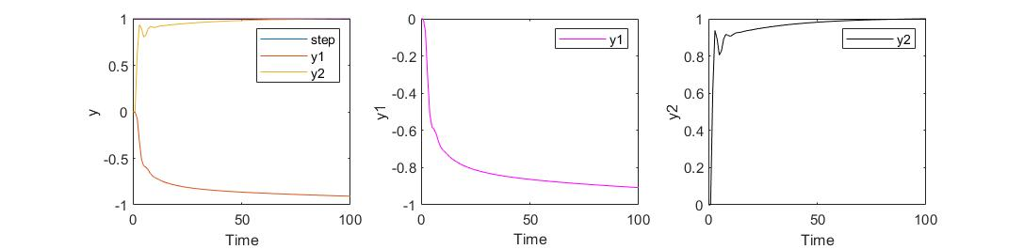

**Figure 9.** Response curve based on the ILC approach.

#### Reinforcement learning

Sigaud et al. indicated that the deep deterministic policy gradient (DDPG) algorithm with four networks (Critic network, Target Critic network, Actor network, and Target Actor network) was suitable for searching control strategies in continuous control problems [27]. Since this dual-loop system included two control loops, we built a multi-agent system with the DDPG algorithm [26]. In this sense, we established two RL agents to perform reinforcement learning decoupling control. The key parameters of the DDPG decoupling model are shown in **Appendix**.

In this experiment, the reward functions were specified as follows:

Reward1 for RL Agent1=10(|y1error|>10)-1(|y1error|≤10)-20(y1>0||y1≤-20) (22)

Reward2 for RL Agent2=10(|y2error|<0.1)-1(|y2error|≥0.1)-20(y2<0||y2≥13) (23)

After 80 training episodes, the two controllers’ PI parameters were achieved as Kp1 = 0.2, Ki1 = 1 x 10-6,Kp2 = 1, Ki2 = 0.2. The OAI was achieved as 52.9461.

The response curves based on obtained PI controller parameters are shown in Figure 10.

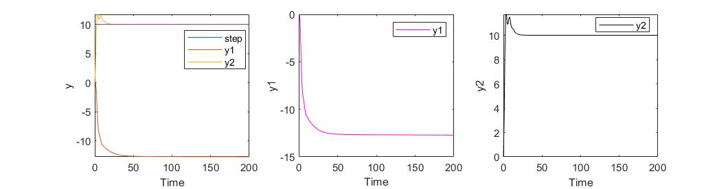

**Figure 10.** Response curves based on the DDPG approach.